Few shot prompt:

Few-shot prompting is a prompt engineering technique where you provide a language model with a few examples of input-output pairs before asking it to perform a similar task. These examples help the model understand the desired format, style, and behavior.

Also, it is like giving direct prompt along with some examples.
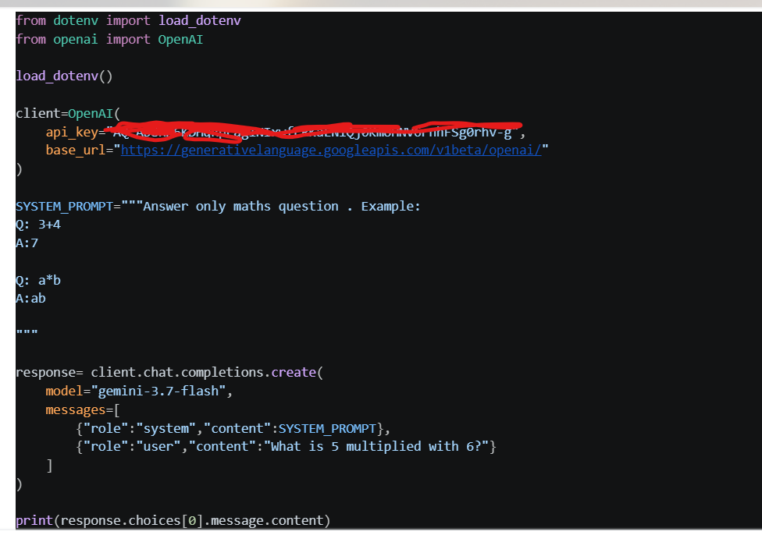

Output:
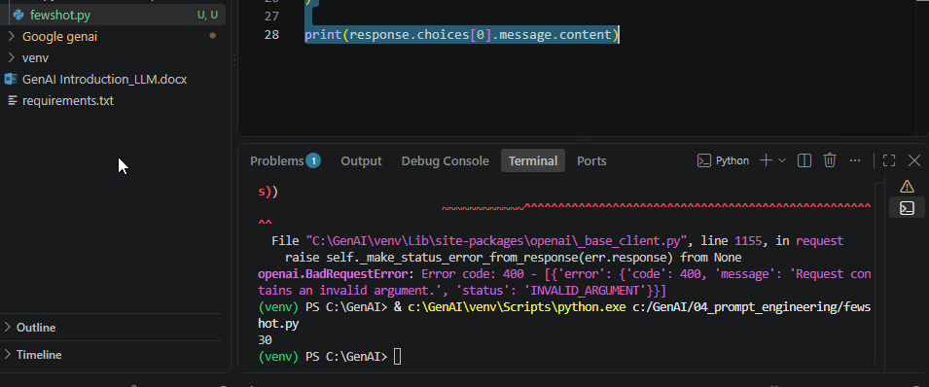

Improve output quality.Bind output quality,structure of LLM as well

